
NAME: RACHITHA.R
REG-NO: 192421058
SUBJECT: COMPUTER VISION FOR IMAGE SEGMENTATION
SUBJECT-CODE: ITA0528
DATE: 26.02.2026
EXPERIMENT -06
Code:
import cv2
import numpy as np
img = cv2.imread("sample.jpg")
kernel = np.ones((5,5), np.uint8)
eroded = cv2.erode(img, kernel, iterations=1)
cv2.imshow("Original Image", img)
cv2.imshow("Eroded Image", eroded)
cv2.waitKey(0)
cv2.destroyAllWindows()
Input:
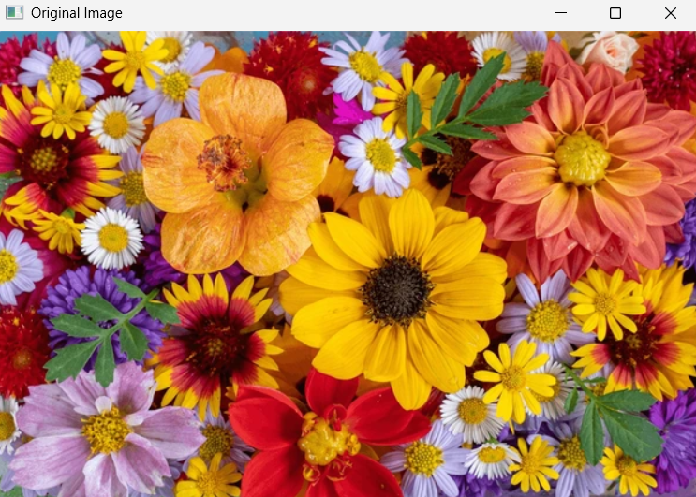
Output:
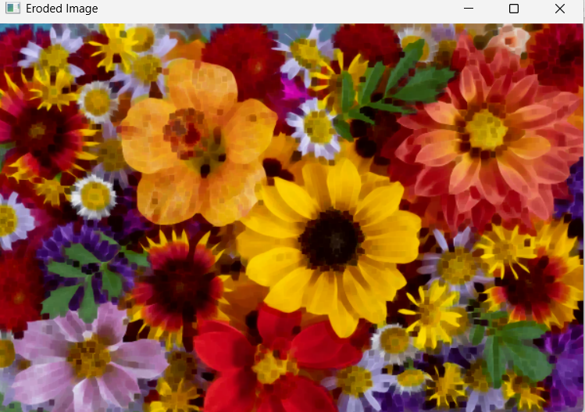
EXPERIMENT -07
Code:
import cv2
cap = cv2.VideoCapture("video.mp4")
while cap.isOpened():
ret, frame = cap.read()
if not ret:
break
cv2.imshow("Video", frame)
if cv2.waitKey(30) & 0xFF == ord('q'):
break
cap.release()
cv2.destroyAllWindows()
output:
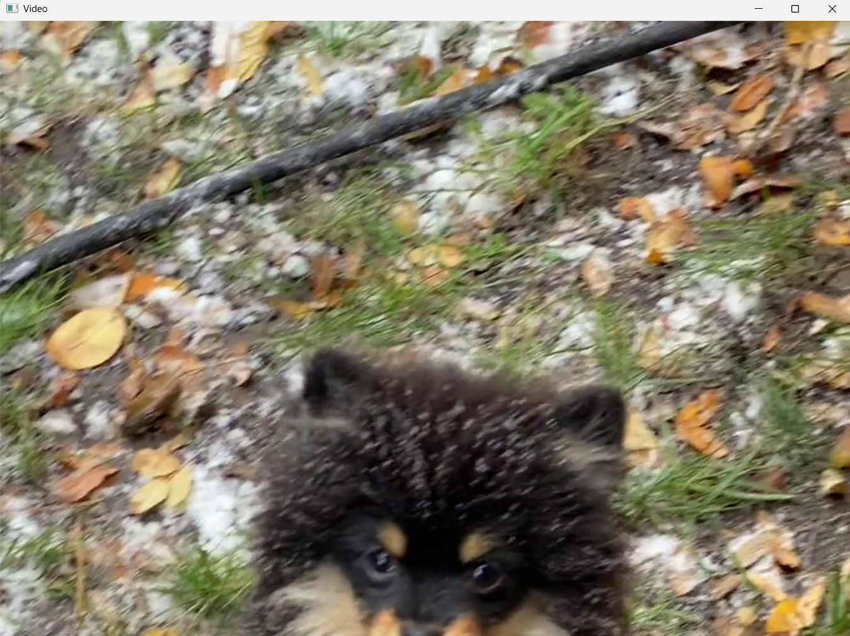

EXPERIMENT -08
Code:
import cv2
import numpy as np
img = cv2.imread("sample.jpg")
kernel = np.ones((5,5), np.uint8)
dilated = cv2.dilate(img, kernel, iterations=1)
cv2.imshow("Original Image", img)
cv2.imshow("Dilated Image", dilated)
cv2.waitKey(0)
cv2.destroyAllWindows()
Input:
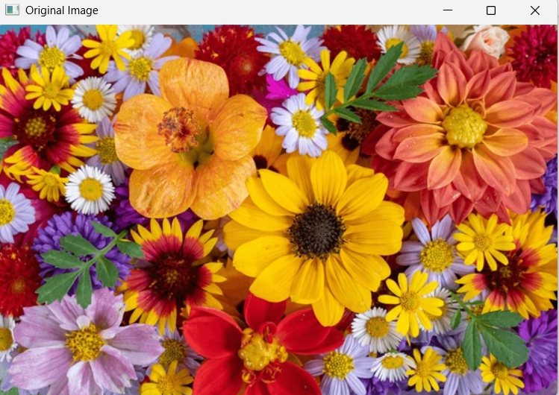
Output:
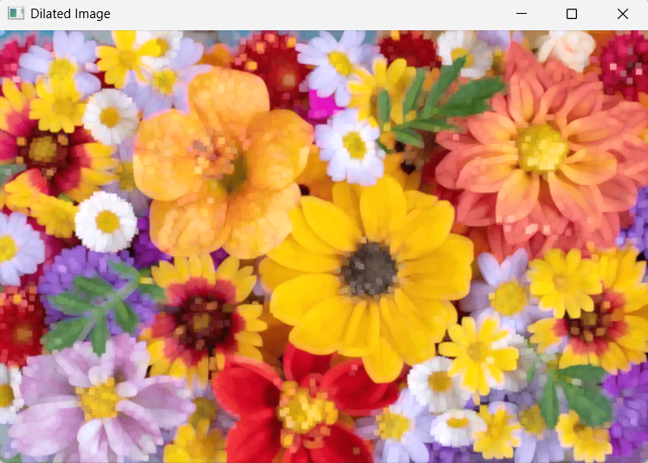

EXPERIMENT -09
Code:
import cv2
img = cv2.imread("sample.jpg")
big = cv2.resize(img, None, fx=2, fy=2)
small = cv2.resize(img, None, fx=0.5, fy=0.5)
cv2.imshow("Original Image", img)
cv2.imshow("Bigger Image", big)
cv2.imshow("Smaller Image", small)
cv2.waitKey(0)
cv2.destroyAllWindows()
Input:
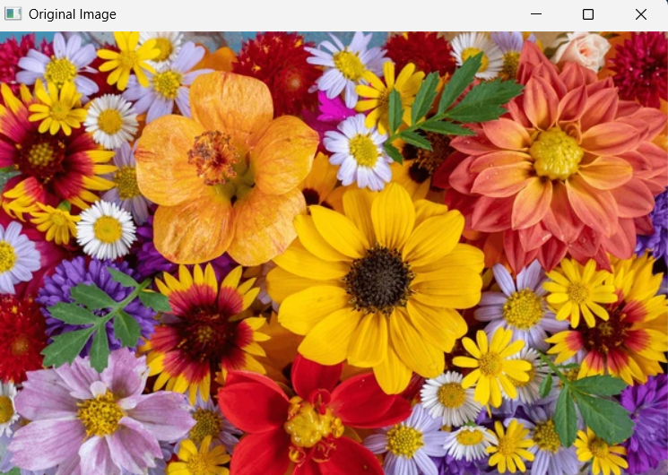
Output:
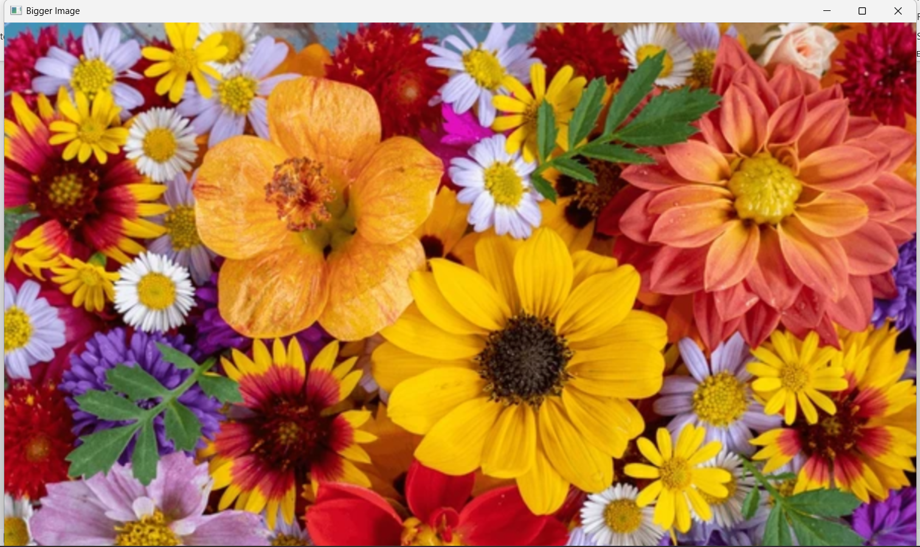

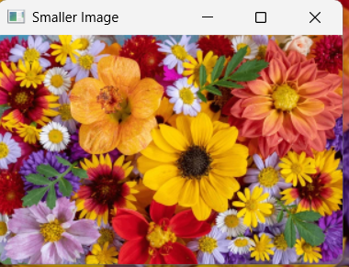

EXPERIMENT -10
Code:
import cv2
img = cv2.imread("sample.jpg")
rotated = cv2.rotate(img, cv2.ROTATE_90_CLOCKWISE)
cv2.imshow("Original Image", img)
cv2.imshow("Rotated Image", rotated)
cv2.waitKey(0)
cv2.destroyAllWindows()
Input:
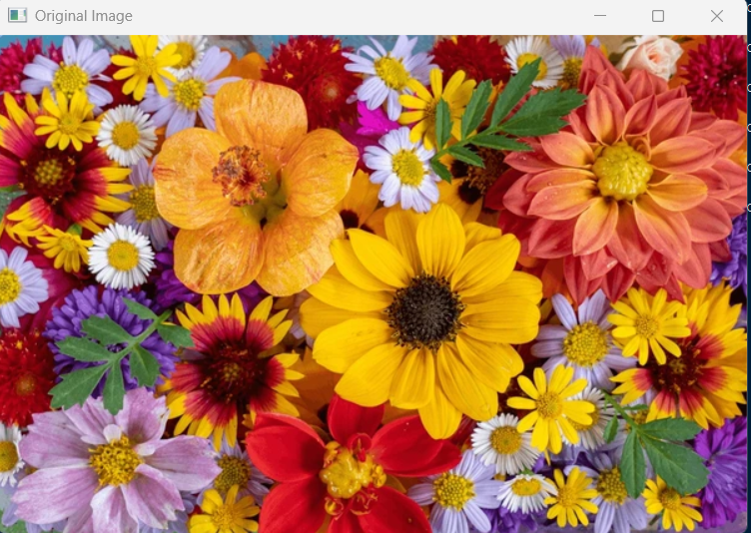
Output:
